

**DEMO PHN  
Practice Report**

Outcome Health provides this report as a snapshot of your general practice data to enable you to focus on patient care and opportunities for improvement.

The report includes Clinical, Business, Data Quality, Quality Improvement, Hospitalisation risk, MyMedicare, Accreditation, Benchmarking and more.





These reports are distributed quarterly, but are available monthly on request via the following email: [support@outcomehealth.org.au](mailto:support@outcomehealth.org.au)

**To access the latest live data log in to** [**polarexplorer.org.au**](https://polarexplorer.org.au/)

POLAR

Practice Report 01/09/2025

Most recent logins

Dr Who - 06/08/25

Dr Seuss - 11/07/25

Dr Doogie Howser - 26/06/25

Patient demographics

## Patient count

|  |  |
| --- | --- |
| Measure | Patient counts |
| Total active patient population | 34,823 |
| Total RACGP active population (3 or more visits in 2 years) | 9,500 |
| Indigenous population - active | 213 |
| Indigenous population – RACGP active | 79 |

## Age profile (active patients) <yBsudC>

Based on your patient profile, which cohort would you prioritise for review? For example, you could focus on childhood immunisations, Health Assessments for 45-49 or 75+

CIS active patients, RACGP active and inactive splits for male and female categories, other/intersex & not recorded CIS active, RACGP active or inactive

**Note**: Patient counts will only be displayed on the chart if there is enough space.

|  |  |  |  |  |  |
| --- | --- | --- | --- | --- | --- |
|  | Female CIS Active & RACGP Active (5,317) |  | Male CIS Active & RACGP Active (4,174) |  | Other/Intersex CIS Active (7) |
|  |  |  |  |  |  |
|  | Other Female CIS Active (13,151) |  | Other Male CIS Active (11,549) |  | Not Recorded CIS Active (625) |

Demographic and clinical data quality

Which quality measures would you focus onimproving for the next 6 months?

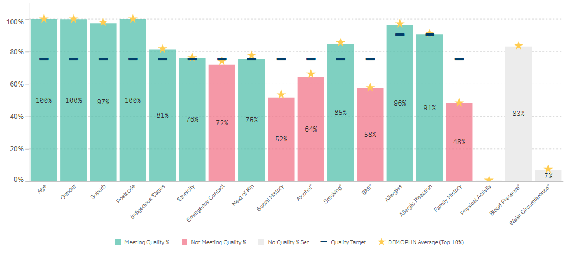

|  |  |  |
| --- | --- | --- |
| **Recording guidelines** | **★ Benchmark values ★** | **Notes** |
| * SNAP: Smoking status: ≥ 10 years * SNAP: BMI: > 18 years, every 2 years * SNAP: Alcohol consumption: ≥ 15 years * RACGP: 90% of allergies recorded * RACGP: a current health summary for at least 75% of active health records | * Calculated based on the average of the top performing 10% of practices for each recorded measure | * Based on RACGP active patient population * BMI figures are based on records with no specified date range * Smoking Status Recorded for ≥ 10 years * Asterisks indicate age specific cohorts are used * Physical activity, blood pressure and waist circumference are included in the RACGP recommendations, however there are no set targets. |

Practice incentive program (PIP) quality improvement measures (QIM)

|  |  |  |  |  |  |
| --- | --- | --- | --- | --- | --- |
|  | Improving measure |  | Deteriorating measure |  | Measure influence outside of practice control or highly seasonal e.g. flu |

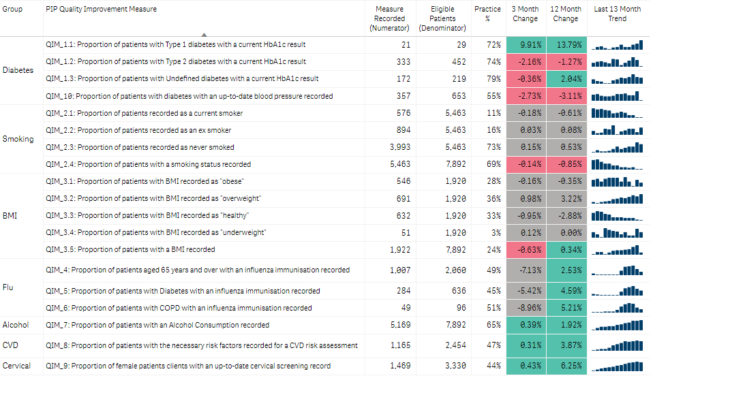

Which QIM would you focus on improving for the next PIP quarter?

**Tip**: Open the PIP QI report to identify these patients in POLAR

<xbrrJ>Diagnosis and Prevalence including chronic conditions

How does the information about medical condition prevalence inform your practice activities?

How does your practice compare with your Local Area?

|  |  |  |
| --- | --- | --- |
| Top 20 coded diagnoses |  | Prevalence of Chronic Conditions in your practice *Active Patients, Active Diagnosis* |
| <JPCzePn> |  | |  |  |  | | --- | --- | --- | | Chronic conditions | Practice Prevalence % | LGA  Prevalence % | | Alcohol and other drugs  (AoD) | 0.3% | 0.3% | | Cancer | 1.7% | 1.7% | | Cardiovascular | 12.0% | 12.0% | | Chronic Kidney Disease  (CKD) | 0.2% | 0.2% | | Dementia/Alzheimer’s | 0.3% | 0.3% | | Diabetes | 3.3% | 3.3% | | Disability | 1.1% | 1.1% | | Mental Health | 7.0% | 7.0% | | Musculoskeletal | 6.6% | 6.6% | | Respiratory | 5.7% | 5.7% | | *Comparison LGA: Whitehorse (C)* | | | |

Patients at Risk of Hospitalisation

The Hospitalisation Avoidance Tool (HAT) report calculates the risk of hospitalisation or emergency presentation within 12 months.

In the table below, for patients identified as either “Urgent” or “High Risk”, eligible MBS item counts are shown.

The percentages indicate the proportion of the at risk patients that are eligible for the relevant MBS services.

**Note**: these percentages will appear to add up to more than 100% as patients can be eligible for multiple services)

|  |  |  |  |  |  |  |
| --- | --- | --- | --- | --- | --- | --- |
| **MBS Item** | **Urgent Risk Patients** | **Urgent Risk Patient %** | **High Risk Patients** | **High Risk**  **Patient %** | **No. of Claims**  **(Aug-2025)** | **Items Eligible** |
| GP Chronic Condition Management Plan | 208 | 75% | 642 | 85% | 188 | 3,764 |
| GP Chronic Condition Management Plan review | 0 | 0% | 0 | 0% | 3 | 0 |
| GP Mental Health Plan | 96 | 35% | 238 | 31% | 34 | 730 |
| GP Mental Health Plan review | 47 | 17% | 78 | 10% | 18 | 431 |
| Chronic Disease Nurse Assessment | 169 | 61% | 401 | 53% | 33 | 1,771 |
| 45-49 Health Assessment | 3 | 1% | 22 | 3% | 8 | 367 |
| 75+ Health Assessment | 113 | 41% | 276 | 36% | 14 | 765 |
| Home Medication Review | 242 | 87% | 597 | 79% | 2 | 2,046 |
| Heart Health Check | 239 | 86% | 668 | 88% | 5 | 6,154 |
|  | **278** | **100%** | **759** | **100%** | **305** | **16,028** |

MyMedicare Registrations

The table above provides an opportunity to prioritise and recall patients at risk of hospitalisation.

How does this information influence your activities to prioritise patients at risk of hospitalisation?

For example, you could review urgent risk patients who haven’t had a service provided.

Registration Rate: 7% (672 of 9,500 patients)

*Percentage of Clinic Active & RACGP Active patients who are registered for MyMedicare. (PHN Top 10% Avg Registration Rate: 7%)*

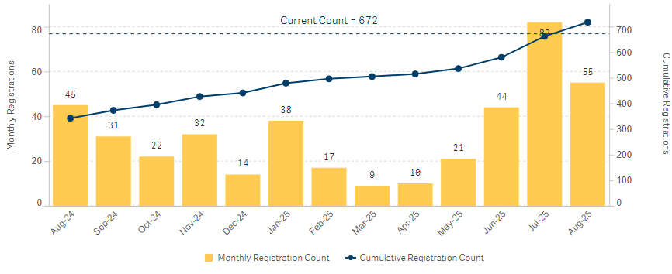

How can you use this information to increase MyMedicare Registrations at your practice?

For example you may focus on percentage registration rate when discussing this with your team.

My Health Record - Shared Health Summary (SHS) Patient Uploads

|  |  |  |
| --- | --- | --- |
| Provider | This Quarter (36) | Last Quarter (127) |
| Valentino Rossi | 9 | 6 |
| Dr Strange | 4 | 16 |
| Desmond Tutu | 4 | 14 |
| Dr Seuss | 4 | 12 |
| Dr Dolittle | 4 | 11 |
| Morgan Freeman | 3 | 13 |
| Indiana Jones | 3 | 11 |
| Dr Richard Kimble | 3 | 9 |
| Dr Doogie Howser | 2 | 17 |
| Dr Who | 0 | 18 |

**Note**: Reports issued in **February**, **May**, **August** and **November** will show a 0 for Shared Health Summary uploads due to the commencement of a new PIP Quarter.Model for Improvement and Plan Do Study Act (PDSA)

Your PHN have developed an editable [PDSA template](https://polarexplorer.org.au/) to support you with quality improvement activities at your practice.

This template will assist you with focusing on your practice priorities each quarter

## Support

For support with POLAR contact [support@outcomehealth.org.au](mailto:support@outcomehealth.org.au)

For quality improvement support contact [support@outcomehealth.org.au](mailto:digitalhealth@emphn.org.au)

## PIP-QI Current and upcoming quarters

|  |  |  |
| --- | --- | --- |
| PIP Quarter | Start Date | End Date |
| Q4 2025 | 01/08/2025 | 31/10/2025 |
| Q1 2026 | 01/11/2025 | 31/01/2026 |
| Q2 2026 | 01/02/2026 | 30/04/2026 |
| Q3 2026 | 01/05/2026 | 31/07/2026 |

[PIP QI guidelines](https://www.health.gov.au/resources/collections/practice-incentives-program-quality-improvement-incentive-guidance)

## Data glossary

|  |  |
| --- | --- |
| Item | Definition |
| Total active patient population | Patients marked Active / Enabled within the Clinical Information System (CIS) |
| Total RACGP active population | Patients who have visited the clinic on 3 or more occasions (separate days) over a two-year period |
| Indigenous population - active | Indigenous patients marked Active / Enabled within the Clinical Information System (CIS). |
| Indigenous population - RACGP active | Indigenous patients who have visited the clinic on 3 or more occasions (separate days) over a two-year period. |
| Coded diagnosis (SNOMED) | This is what a clinical diagnosis entered into the CIS is mapped to by the POLAR system.   * SNOMED is an international standard for defining medical terms and is the preferred coding system for Primary Care environments. |